KOffice UI and Functionality Example
by KOffice User, koffice_user@gmail.com

Created using KWord, Krita, Inkscape and OpenOffice.org Writer – you pick your tools
- Synopsis

This is an example of a fraction of what a KOffice UI and functionality submission could be like. You are free to use any existing applications — you don't need to be using KOffice already — and use a graphic editor like Kivio, Inkscape, the GIMP or Krita to create a mock-up of your vision of the future KOffice user itnerface. The whole purpose is to freely explore possible answers to the question "how would most people use KOffice most efficiently with your UI and functionality design".
- User Interface
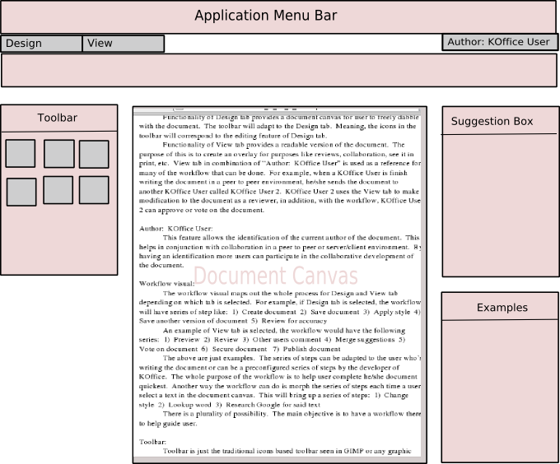
  - Menu Bar:
To keep with tradition this is there. It is collapsable, so only “Design” and “View” are to be seen as the top visual.
  - Design and View tabs:
This is new. Design tab when click opens the document for editing. View tab when click opens the document for viewing. This is parallel to the document and view model used in the development of KOffice.
Functionality of Design tab provides a document canvas for user to freely dabble with the document. The toolbar will adapt to the Design tab. Meaning, the icons in the toolbar will correspond to the editing feature of Design tab.
Functionality of View tab provides a readable version of the document. The purpose of this is to create an overlay for purposes like reviews, collaboration, see it in print, etc. View tab in combination of “Author: KOffice User” is used as a reference for many of the workflow that can be done. For example, when a KOffice User is done writing the document in a peer-to-peer environment, he or she sends the document to another KOffice User called KOffice User 2. KOffice User 2 uses the View tab to make modification to the document as a reviewer, in addition, with the workflow, KOffice User 2 can approve or vote on the document.
  - Author: KOffice User:
This feature allows the identification of the current author of the document. This helps in conjunction with collaboration in a peer to peer or server/client environment. By having an identification more users can participate in the collaborative development of the document.
  - Workflow visual:
The workflow visual maps out the whole process for Design and View tab depending on which tab is selected. For example, if Design tab is selected, the workflow will have series of step like: 1) Create document 2) Save document 3) Apply style 4) Save another version of document 5) Review for accuracy
An example of View tab is selected, the workflow would have the following series: 1) Preview 2) Review 3) Other users comment 4) Merge suggestions 5) Vote on document 6) Secure document 7) Publish document
The above are just examples. The series of steps can be adapted to the user who is writing the document or can be a preconfigured series of steps by the developer of KOffice. The whole purpose of the workflow is to help user complete he/she document quickest. Another way the workflow can do is morph the series of steps each time a user select a text in the document canvas. This will bring up a series of steps: 1) Change style 2) Lookup word 3) Research Google for said text.
There is a plurality of possibilities. The main objective is to have a workflow there to help guide user.
  - Toolbar:
Toolbar is just the traditional icons based toolbar seen in GIMP or any graphic design application.
  - Document Canvas:
Where document is edited or review for comments.
  - Suggestion Box:
A user can right click in the document canvas to have the suggestion box popup with something. A user can select a right click and search Google for more content on the search term/terms.
Another use for this is when a user writes something and want to search through his/her previous documents to retrieve it for the current document. Instead of the user manually going through old documents, the Suggestion Box will do that indexing of all the user’s document to provide that suggestion so the user can insert immediately in the document canvas.
  - Examples:
Examples are style oriented. By reading the tabs, and placements of text in the document canvas, KOffice will provides examples of style user can choose from. Think of templates to present to user when composing a document.
  - Document Navigation:
Allow the side by side view of two documents. Allow the opening of multiple documents. This is the area where the documents are organized in such a way for easy retrieval.

